**Assignment 2: Mitesh Sharma**

**___________________________________________________**

**Steps for installing Jenkins**

* **Java**:

**>>** sudo yum install java-1.8.0-openjdk

**>>** java -version

* **Install Apache Tomcat 9:**

**>>** sudo yum install wget [**http://www-eu.apache.org/dist/tomcat/tomcat-9/v9.0.0.M21/bin/apache-tomcat-9.0.0.M21.tar.gz**](http://www-eu.apache.org/dist/tomcat/tomcat-9/v9.0.0.M21/bin/apache-tomcat-9.0.0.M21.tar.gz)

**>>** chmod 755 apache-tomat-9.0.0.M21.tar.gz

tar xzf apache-tomat-9.0.0.M21.tar.gz

**>>** vi /home/kkavuri/tomcat9/conf/tomcat-users.xml

<?xml version="1.0" encoding="UTF-8?>

<tomcat-users>

<pre><role rolename="manager-gui"/>

<role rolename="manager-script"/>

<role rolename="manager-jmx"/>

<role rolename="manager-status"/>

<role rolename="admin-gui"/>

<role rolename="admin-script"/>

<user username="kkavuri" password="xxxxx" roles="manager-gui,manager-<wbr />script,manager-jmx,manager-<wbr />status,admin-gui,admin-script"<wbr />/>

</tomcat-users>

>> cd tomcat9

>> ./bin/startup.sh

* **download Jenkins war file**

>> cd

>> wget<http://updates.jenkins-ci.org/download/war/2.7.3/jenkins.war>

* **Deploy Jenkins war File**

copy the Jenkins.war file in ~/tomcat9/webapps folder

open your browser and access localhost:8080

click on the Manager App

Enter your username and password

OR

For standalone:

>> Java –jar Jenkins.war –httpPort=9090

Get the password from :

>> cat ~/Jenkins/Home/secrets/initialAdminPassword

* **Install Suggested Plugins**

Follow the onscreen steps to install the suggested plugins

**______________________________________________________**

**install java**

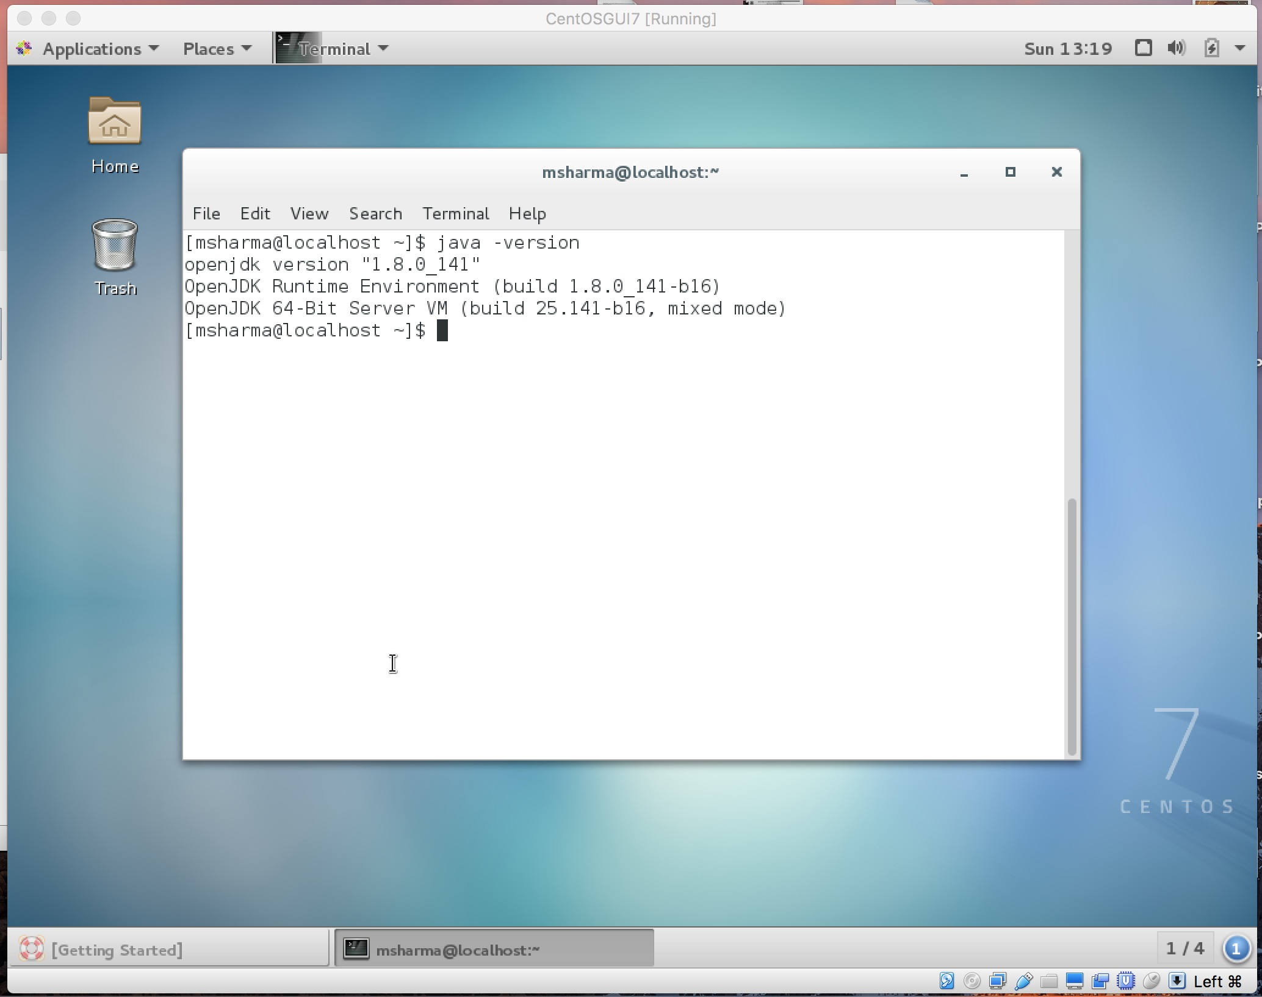

tomcat downloaded

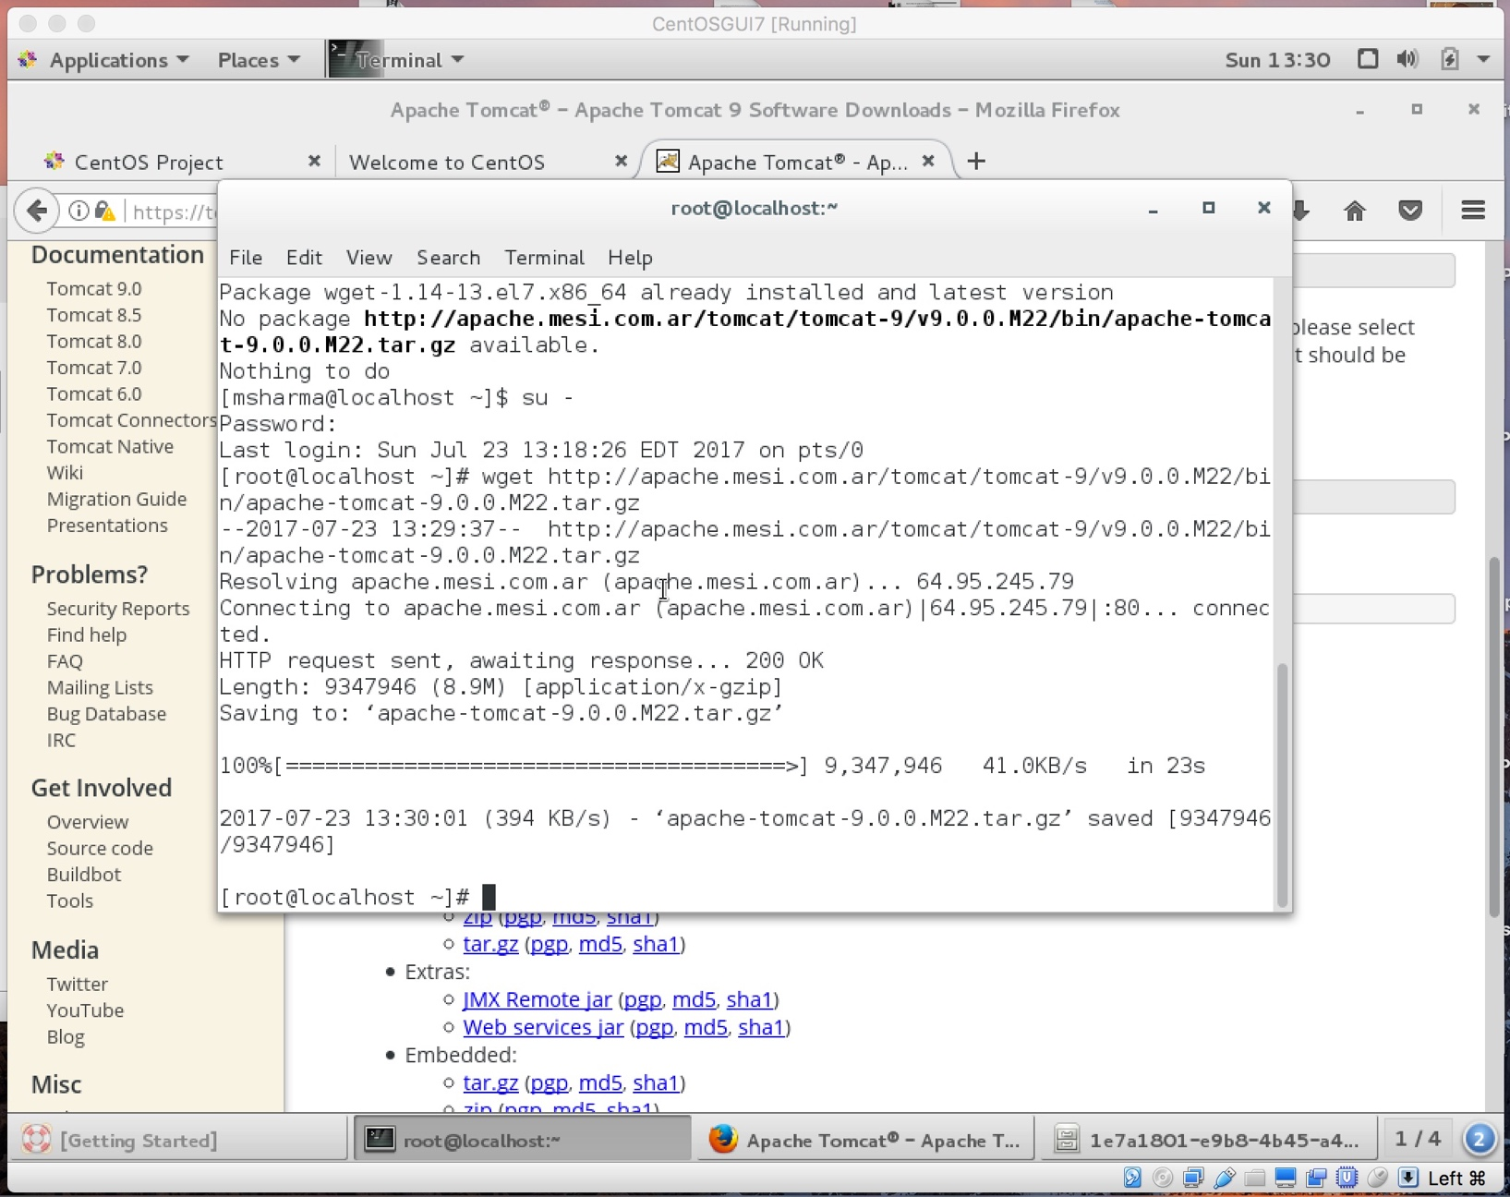

tomcat installed

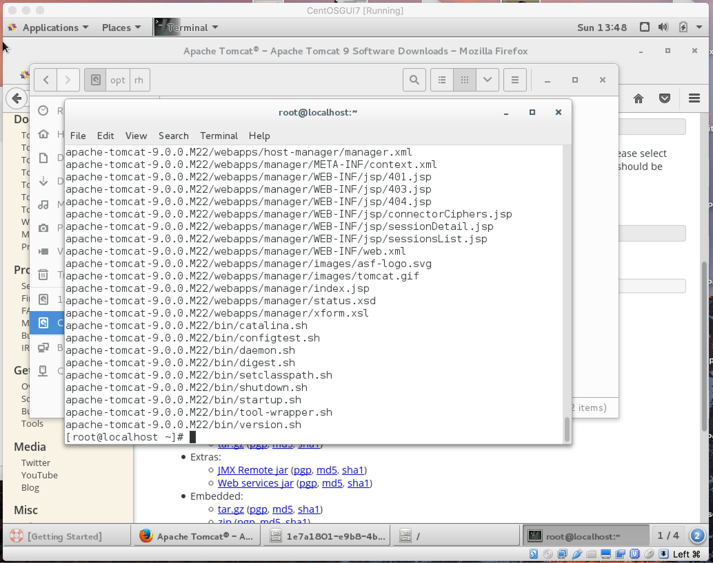

tomcat started

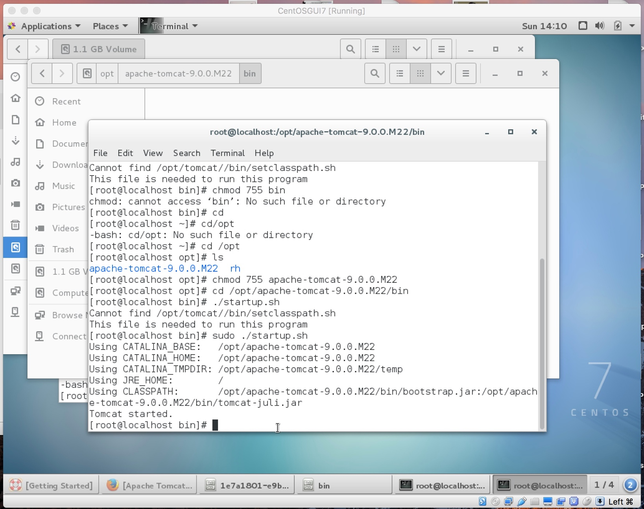

Jenkins saved

